

|  |  |  |  |  |  |  |  |  |
| --- | --- | --- | --- | --- | --- | --- | --- | --- |
|  | | | | | | | | |
|  | | Assignment . 8 | | | | |  | |
|  |  | | | | | | |  |
|  | | | |  |  | | | |
|  | | | | MujtabaSP22-BSE-036 |  | | | |
|  | | | | Dec 22, 2022—Introduction to Management |  | | | |
|  | | |  | | |  | | |

Build a tower, build a team

Context, from ted.com, “**Tom Wujec** presents some surprisingly deep research into the "marshmallow problem" -- a simple team-building exercise that involves dry spaghetti, one yard of tape and a marshmallow. Who can build the tallest tower with these ingredients? And why does a surprising group always beat the average?”.

Following are the questions and their answers written according to the given video.

1. **Is planning and organizing enough for teamwork?**

We can say that planning and organizing is enough for teamwork because what planning and organizing results in, in my perspective, is to avoid the situations where someone belonging from the team tries to dominate others or the effect of external pressures such as running out of time effects the conduct of the team members. Planning/Organizing literally means to “arrange systematically or in order”. This means no instinctive actions.

Coming back to the question, the teamwork is done effectively when there is more coordination among the members which is possible more when there are planned and organized structure/methods being followed.

Figure : Video context. The image of a marshmellow challange.

1. **Is failure an option when working in teams?**

Practically no. One can fail under any circumstances. And often the control of who will fail or succeed often lies in things not in control of whom controlling a team or an organization.

Now in the context of this assignment, we can say that bad organization may leads to potential failure, as they told in the video that those who rushed and did not effectively prototype eventually failed. But this is not true for all cases.

But my some of the people may disagree with my opinion such as writer in this article does: “We’ve all heard the saying, “Failure is not an option.” While that may seem like a powerful motivational mantra, it’s simply not true in the real world. In business, failure is not only an option, it’s an opportunity.”.[REFERENCE 2]

1. 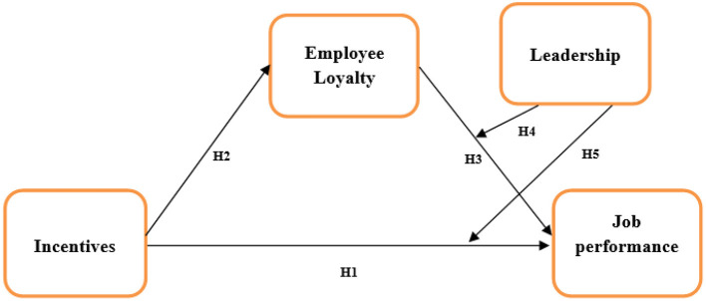**Why does incentive plus skill lead to successful teams?**

Incentive thing motivates the people to do the task. Teams are composed of people. So it directly motivates the joint teamwork. If people in teams are not motivated enough, they will not perform enough.

Conceptual Diagram (above) explained[REFERENCE 1]:

* H1: Incentives have a positive effect on employee loyalty.
* H2: Employee loyalty has a positive effect on job performance.
* H3: Leadership can have a positive moderating effect on employee loyalty leading toward job performance.
* H4: Leadership has a moderating effect on incentives and job performance.
* H5: Incentives have a positive effect on job performance.

References

1. [The Impact of Incentives on Job Performance, Business Cycle, and Population Health in Emerging Economies - PMC (nih.gov)](https://www.ncbi.nlm.nih.gov/pmc/articles/PMC8866177/)
2. [Failure Actually Is an Option | Learn Why Teams Fail (readytrainingonline.com)](https://readytrainingonline.com/articles/failure-employee-teams/)